**Health-Care Domain**

* **Health-care Domain Testing** is a process to test **Health-care** application for various factors like standards, safety, compliance, cross dependency with other entities, etc.
* The purpose of health-care domain testing is to ensure quality, reliability, performance, safety and efficiency of the Health-care application.
* **Why Do We Require An Application In Health-Care Domain..??**

(Note: This Point can be used to answer questions like, what was the need of this application? /What was the business requirement of the application? /What was the business flow of the application you worked on?)

* Whenever a new patient comes to the hospital, we need to do a **new registration** for the patient.
* If existing or new patient needs to schedule an **appointment** with any doctor
* To maintain the **visits** of all patients inside the hospital
* To **maintain the data** of doctors, nurses, other staff etc.
* To **maintain the stock** inside the hospital, the stock can be medicines, surgical instruments, house keeping stock, bed availability etc.
* To submit and validate **claims** for patients.

**Terminologies related to Heath-Care Domain :-**

****1.Insurer:****  
An entity or Insurance Company which creates plan, sell policy and reimburses policy holder or provider for the submitted valid claims.

****2.Policy-Holder:****  
Health-care policyholder (**Insured**) A person or an entity, who buys the policy from the insurer, pays premium to the insurer and sometimes submit claim.

****3. TPA(Third Party Administrator):****  
A person or an entity that manages the claims of policy holder or provider and receives payment for the management from the respective contributor.

(TPA -> Insurance Samadhan => <https://www.insurancesamadhan.com/> )

****4.BROKER:****  
Health-care insurance broker (**Insurance Agent**)  
He is an agent who sells policy to the customers on behalf of insurer and receives commission in return from the Insurer.

****5. Claims –**** “An invoice from the provider to the doctor for the services rendered”.

****6. Co-Insurance –**** A form of medical cost sharing in a health insurance plan that requires an insured person to pay a stated percentage of medical expenses after the deductible amount, if any, was paid.

****7. Co-payment –**** A form of medical cost sharing in a health insurance plan that requires an insured person to pay a fixed dollar amount when a medical service is received. The insurer is responsible for the rest of the reimbursement.

****8. Deductible**** – A fixed dollar amount during the benefit period – usually a year – that an insured person pays before the insurer starts to make payments for covered medical services.

****9. Medicare:**** A federal health insurance program for senior citizen and permanently disabled people.

****10. Medicaid:**** A joint and state program that helps low-income families and individuals pay for the cost associated with medical care.

****11. HIPAA**:** It is a set of rules and regulations which doctors, hospitals, health-care providers and health plan must follow in order to provide their services.

**Name of the Application: PMS (Practice Management Software)**

**Healtrhcare Domain Companies -**

GreenMed / AdvanceMed / PracticeMD / GreenWay / ProviderWay / NextGen / OpenEMR / Medfusion

* **In Which All Departments The Application Can Be Used..??**

The application can be used in all the departments available inside the hospital to provide a smooth service to any patients who is visiting.

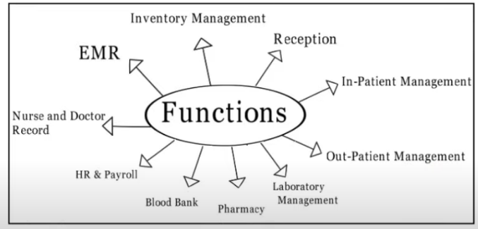

**Business Flow :-**

1. Practice Management Software is having many functionality to manage Hospital/Practice. One of them is **Billing Module**.
2. Most of the Hospital in United State are using **Practice Management Software** for smooth operation in their facility.
3. Using this PMS any Hospital can manage their **Appointment, Scheduling, Maintaining Patient Health Information (PHI), Billing Department, Credit Balance, and Inventory Management.**
4. They can manage their multiple branches using single platform.
5. Using Practice Management Software Hospital can get their reimbursement from Patient Insurance in Short period.

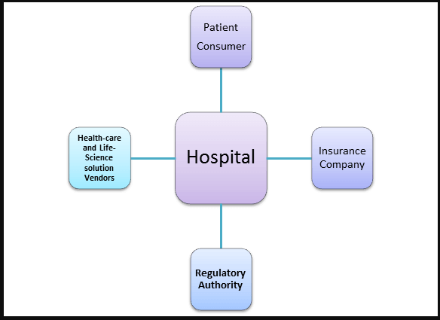

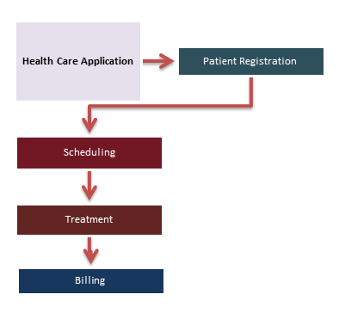

* **Technical Flow:**

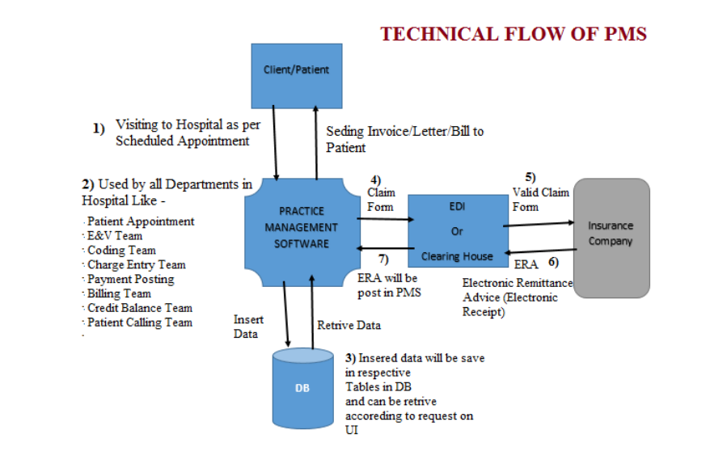

1) When any patient is coming to Hospital for taking service then from usage of PMS will start.

2) If the patient is new for Hospital then need to create new account for that patient in PMS.

3) Who is handing Registration/Patient Appointment team will take patient demographic information and enter into PMS.

4) Doctor will provide the required service to patient and at the same time it will be documented in the form of Medical Records.

5) These medical records will be uploaded into PMS.

6) On the Basis of Medical Records, Coding team will enter service related codes into Practice Management System.

7) Then Charge Entry team will use PMS to enter charges for entered codes by Coding team.

8) From Practice Management Software claim will be bill to patients Insurance Company through selected way – Paper or Electronic.

9) Practice Management Software is integrated with one of the Clearing House or EDI for checking format of the data on claim form and is there any missing information on Claim form which is mandatory.

10) Electronic claim have to pass through EDI / Clearing House and then it will reach to Insurance Company.

11) Once Insurance Company paid for the claim then payment posting team is posting payment on Payment Posting screen.

12) Also if payment received from patient then also posting team is posting payment on Payment Posting screen.

* **Log-In Module:**

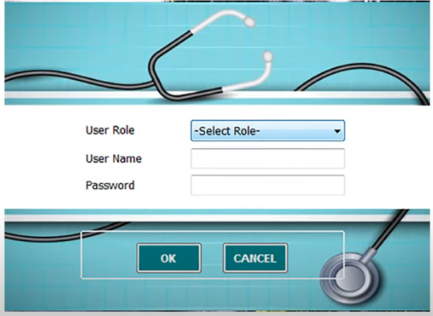

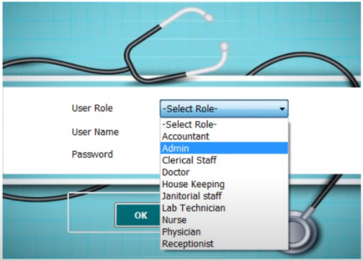

As the PMS, application is used in all the departments of the hospital, the user can login using different user roles available in the login module.

To login successfully inside the PMS application user must fill **User Role, User name and Password** fields correctly.

Expectations (Used to write test scenarios):

* 1. Write test scenarios for each and every user role available in the user role drop-down.
  2. User should be able to login only when all 3 fields are filled up.
  3. User should not be able to login if the username or password fields are wrong.
  4. If any of the field is wrongly inserted, the application should show error messages.

(**Error Message** -> “Please Enter Valid Username/Password” and “Please select a Role”)

* **PMS Basic Screen:**

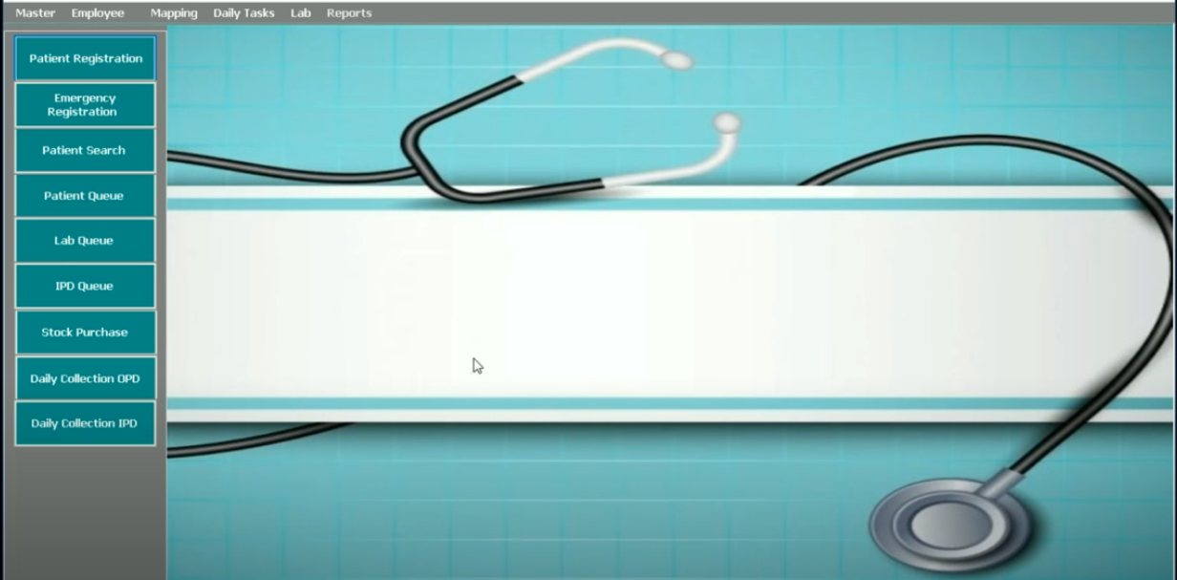

* **Patient Registration:** Used to create a new account for a new patient filling in all the required details
* **Emergency Registration:** Used to register patients who are admitted to emergency section of the hospital
* **Patient Search:** Used to search the patients already registered in the hospital database and using this module appointments can be scheduled for the patients.
* **Patient Queue:** Used by doctors to check appointment list for them
* **Lab Queue:** Used in hospital labs to check for lab tests allocated to patients
* **IPD Queue:** Used to check the IPD patients allocations
* **Stock Purchase:** Used to place orders for stock if in case anything required in the hospital.
* **Daily Collection OPD:** Used to check the date wise collection done inside OPD
* **Daily Collection IPD:** Used to check the date wise collection done inside IPD
* **Master:** Used to add different masters inside the PMS application
* **Patient Registration:**

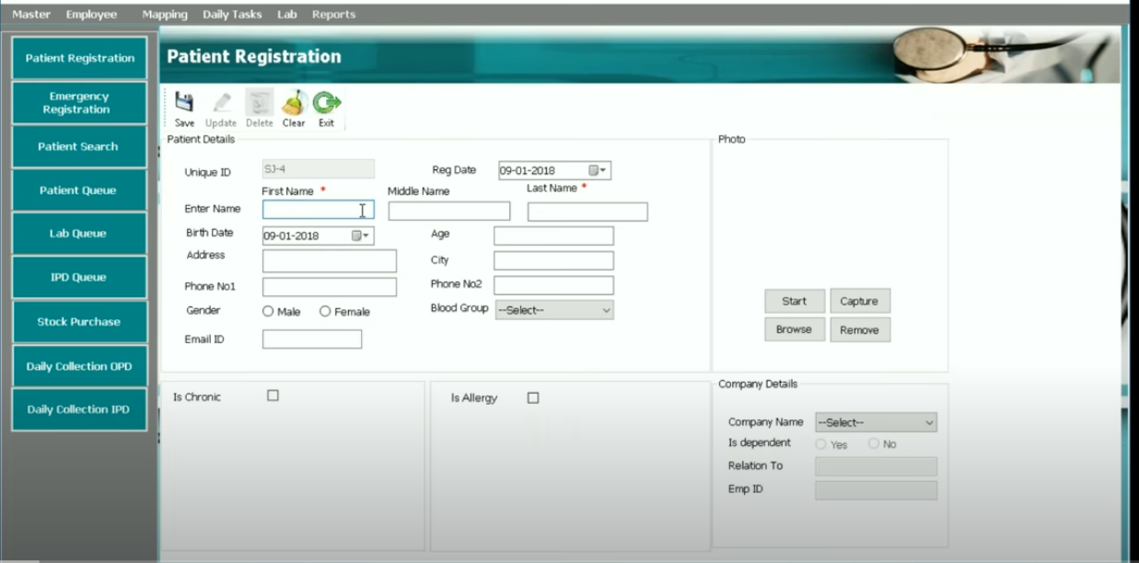

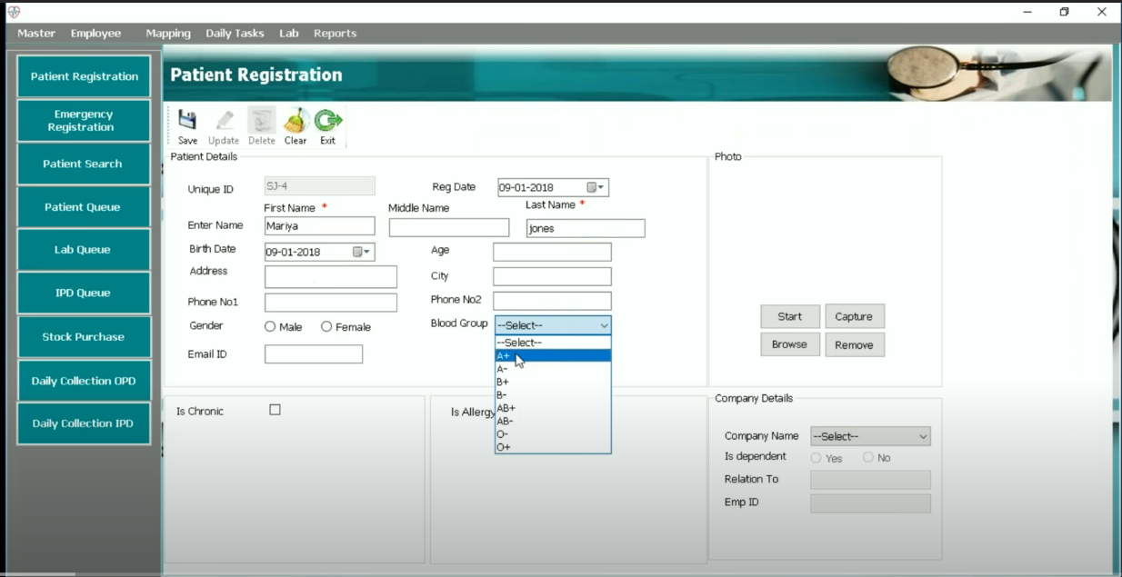

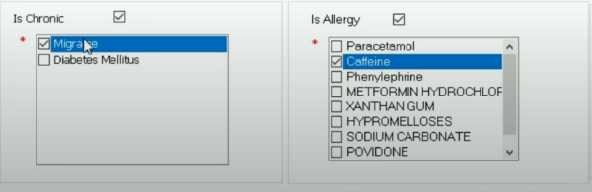

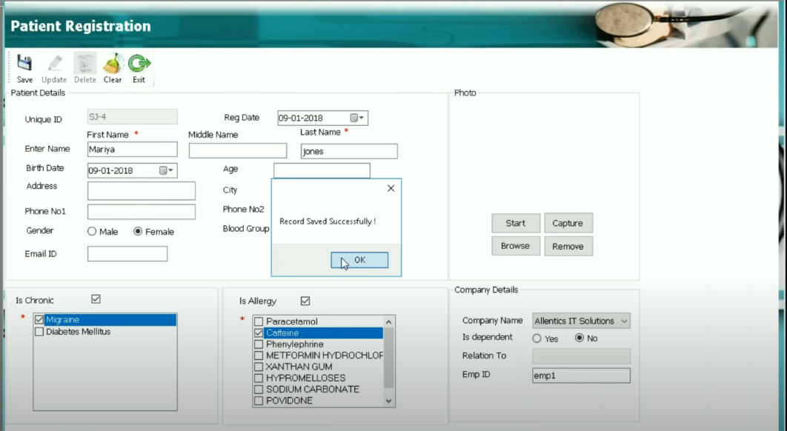

This module is used to register a new patient to the hospital database. To register a new patient, the mandatory fields are Fname and Lname else fields are optional. User can store the Profile picture for the patients as well using the module.

Expectations(Used to write test scenarios):

* 1. Without filling Fname and Lname text fields the save should not work.
  2. Based on registration date and Birth date the age should be calculated automatically.
  3. If the Is-Chronic checkbox is selected, the Chronic disease list should be displayed below where user should be able to select single or multiple options from the list
  4. If the Is-Allergic checkbox is selected, the Medicine list should be displayed below where user should be able to select single or multiple options from the list
  5. To add a profile picture if user clicks on start the camera should open, if user clicks on capture the photo should be clicked, if user clicks on browse user should be able to browse data available in the PC.
  6. If user clicks on save button the data should be saved to database and a pop-up window having confirmation message should be displayed.
  7. If user clicks on clear button, all the fields should be cleared.
  8. When user clicks on exit button, the home screen should be displayed.
* **Patient Search:**

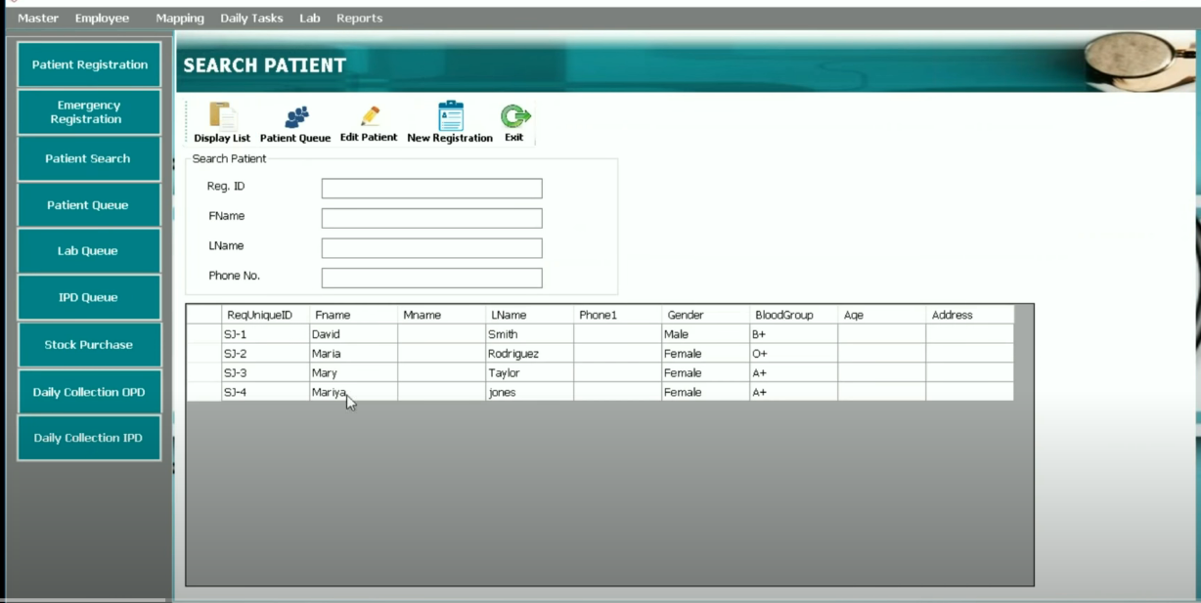

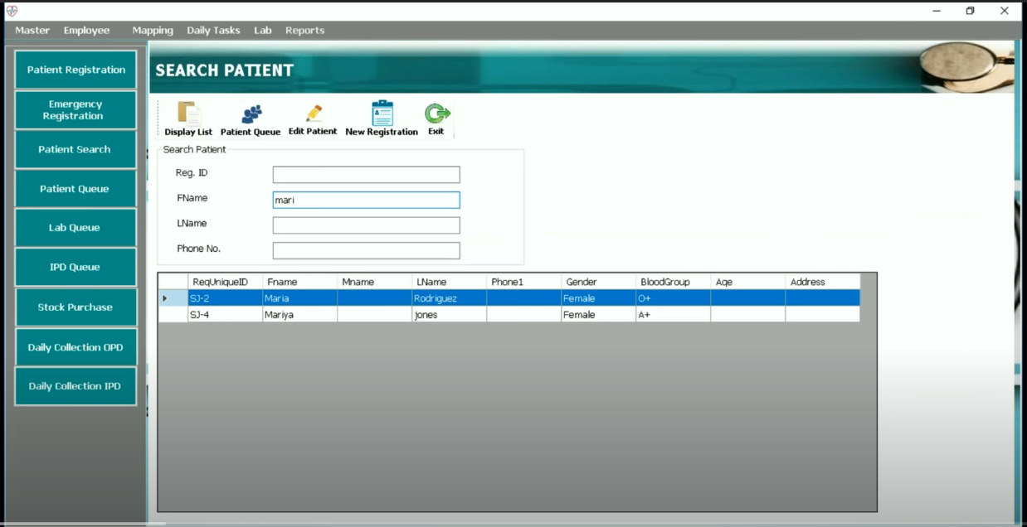

When the Patient search Module is opened, it should display the list of all the patients which are registered with the hospital. Using this module we can schedule appointments for the patients, search for particular patient based on search Patient fields, Edit patient details etc.

Expectations(Used to write test scenarios):

1. When opened the screen, list of all patients registered inside the hospital should be displayed.
2. If User adds data in the search patient text fields, the filtering of records should be done.
3. When user clicks on patient Queue button, user should be able to schedule appointment for the patient 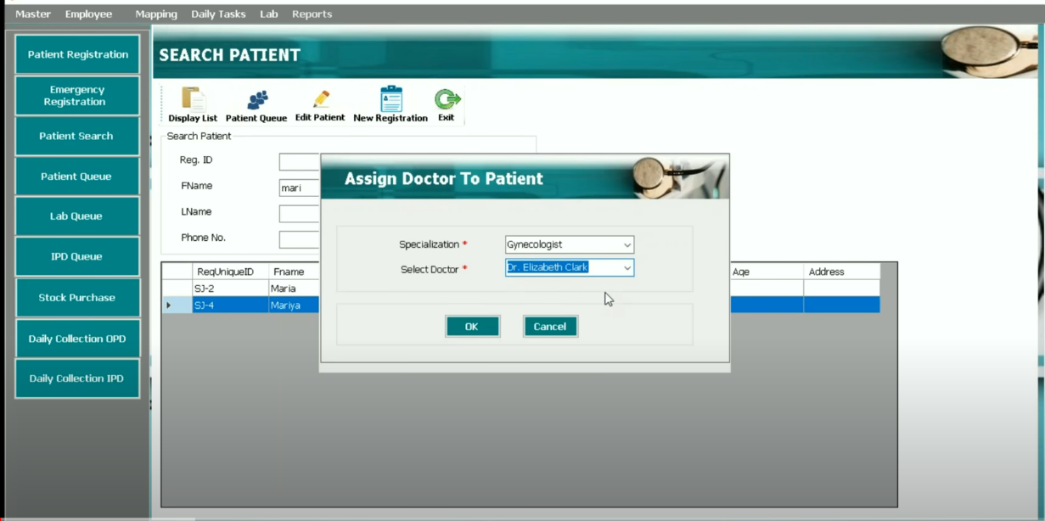
4. To schedule appointment user should be able to select valid combination of specialization and doctor.
5. When user clicks on edit Patient Button, user should be able to edit and save data for patients.

When User clicks on New Registration, user should get diverted to patient Registration tab

* **Patient Queue:**

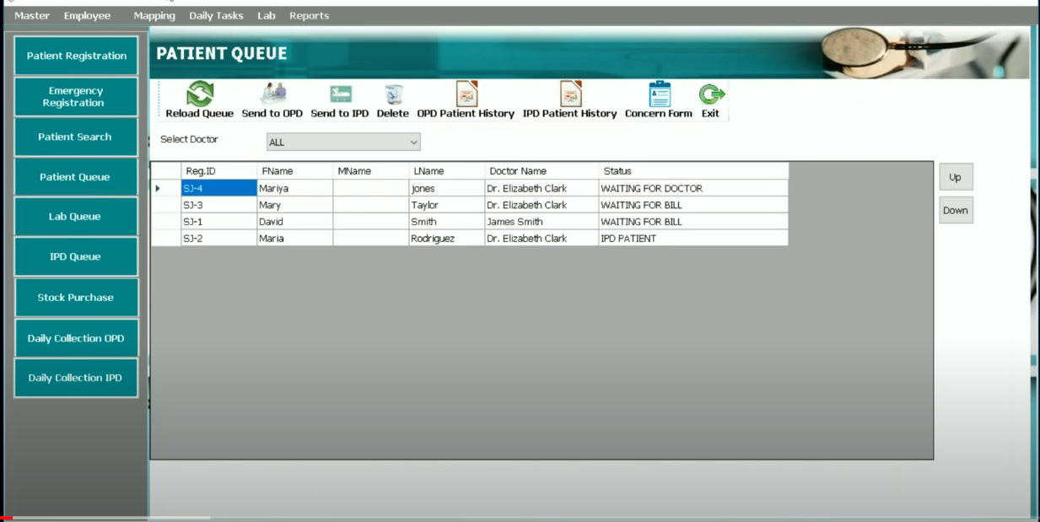

This tab is used by Doctors to see the patient appointments scheduled for them.

Expectations(Used to write test scenarios):

1. When the Patient Queue tab is opened, all the appointments scheduled for the day should be displayed.
2. If doctor selects any name from the select doctor drop-down available, only the appointments scheduled for that particular doctor should be displayed.
3. If doctor selects any patient from the list and clicks on to Send To OPD button, the doctor should be diverted to Patient Visit tab.

* **Patient Visit:**

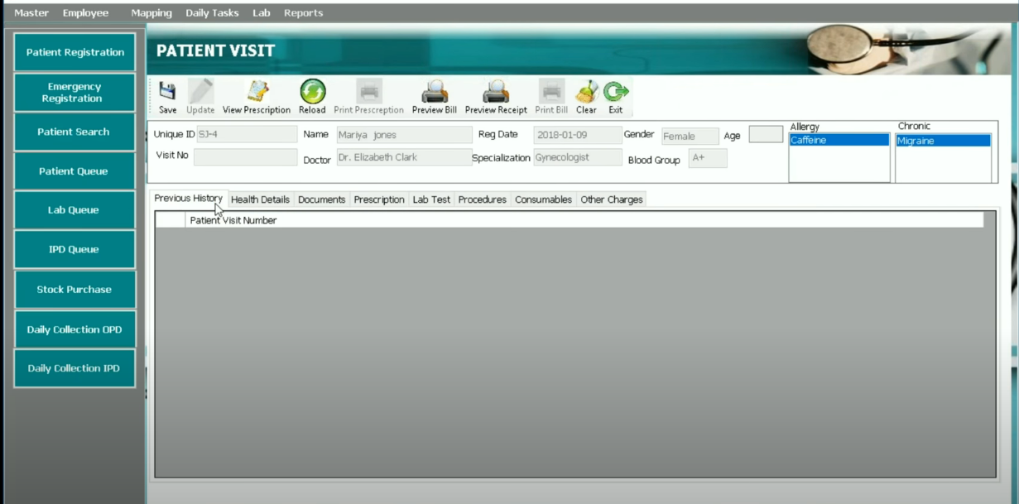

This section is managed only by the doctors. Doctors can add consultation notes for the patients the consult using multiple tabs available.

Expectations(Used to write test scenarios):

1. The patients information should already be filled and the fields should be non-editable by user.

* **Patient History:**



This tab shows the history of the patient if patient has visited the doctor before as well.

* **Health Report:**

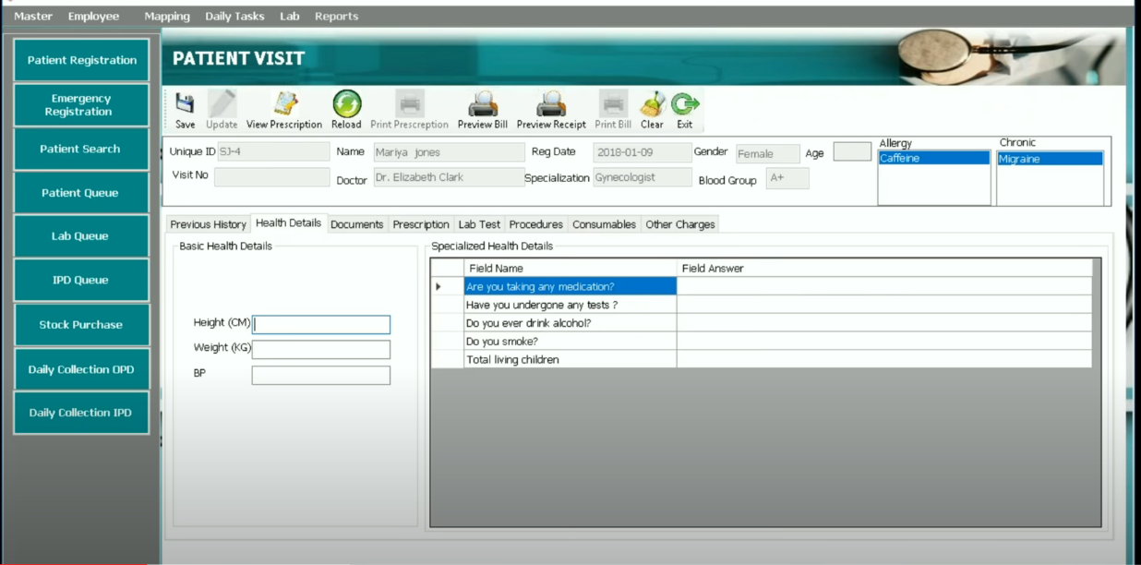

This tab is used by doctors to add basic health details for the patients.

Expectations(Used to write test scenarios):

1. Doctors can add details as Height, weight, BP etc.
2. Doctors can add specialized health details for the patients.
3. User should verify that the specialized health details questions change as per the doctors specialization

* **Documents:**

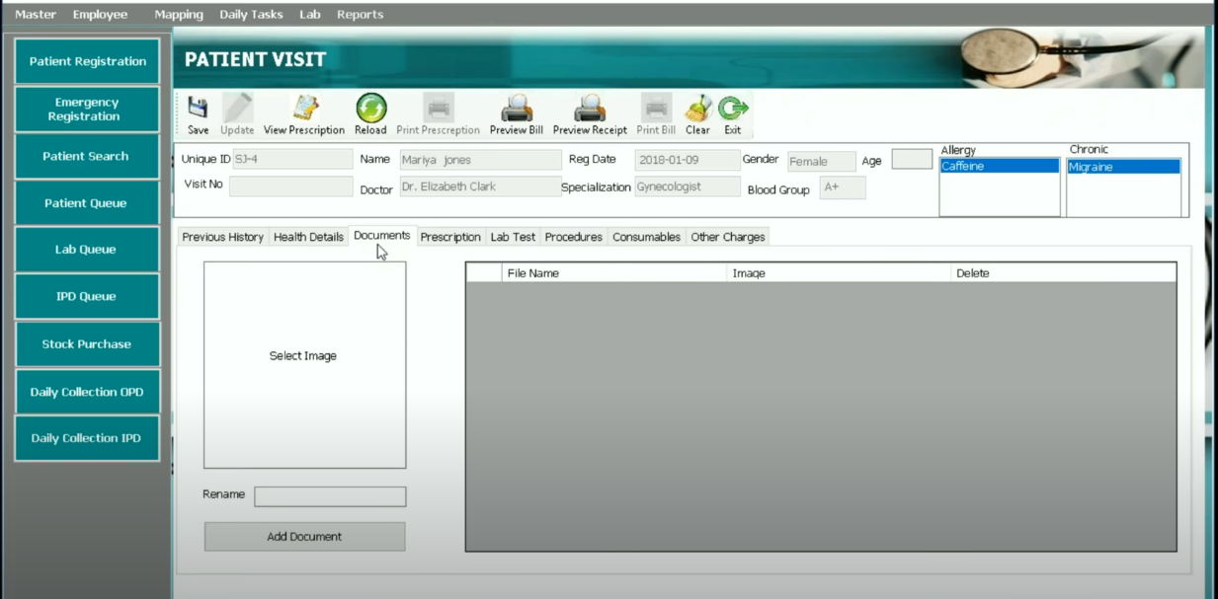

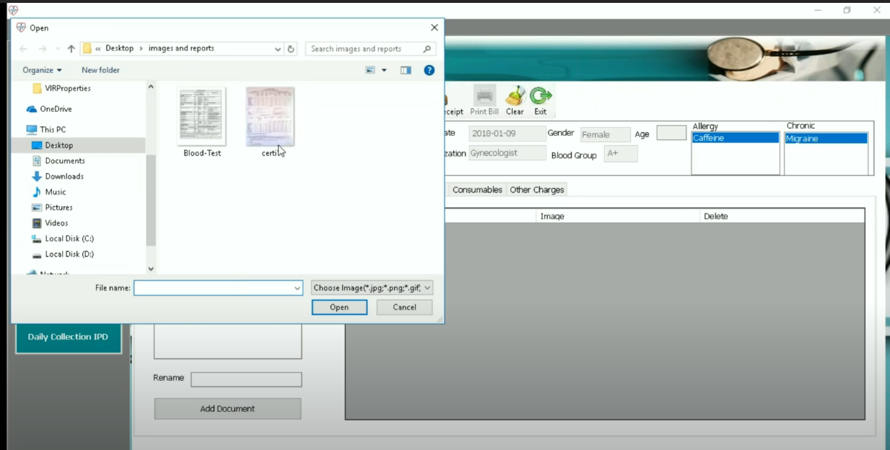

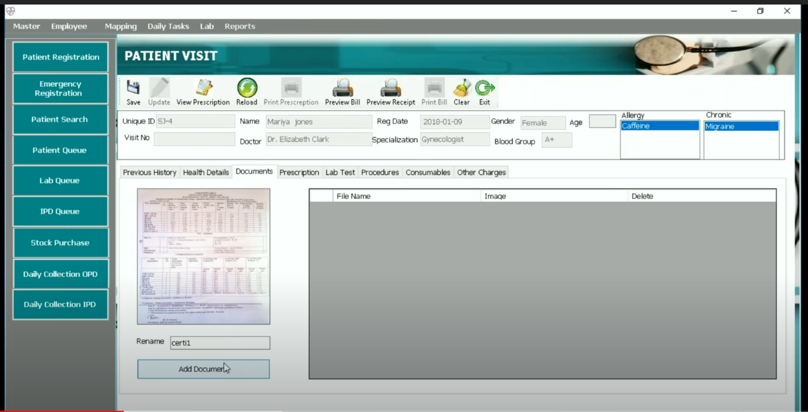

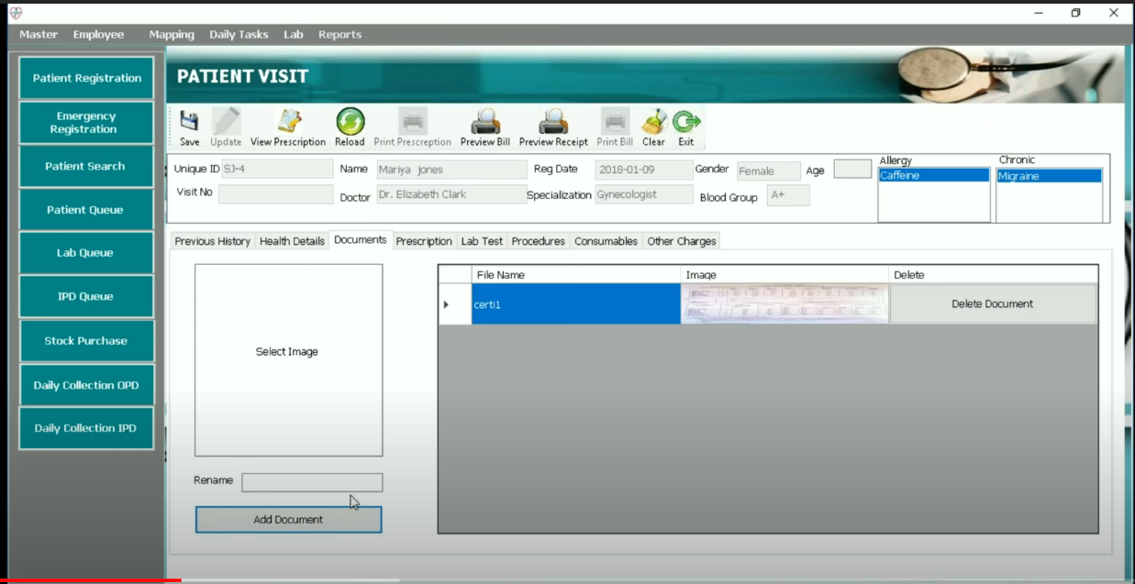

This tab is used to add any lab reports or any health reports for the patient.

Expectations(Used to write test scenarios):

1. When user clicks on select Image button, he should be able to browse the PC for documents.
2. When User clicks on add document button the document should be uploaded and it should be displayed under the tab available on right hand side.
3. When user clicks on Remove document tab the uploaded document should be deleted.

* **Prescription:**

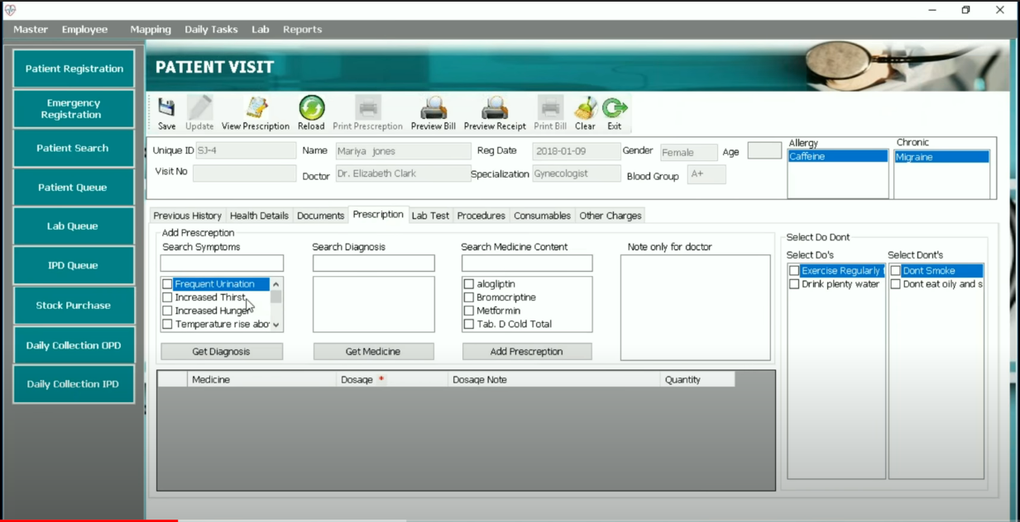

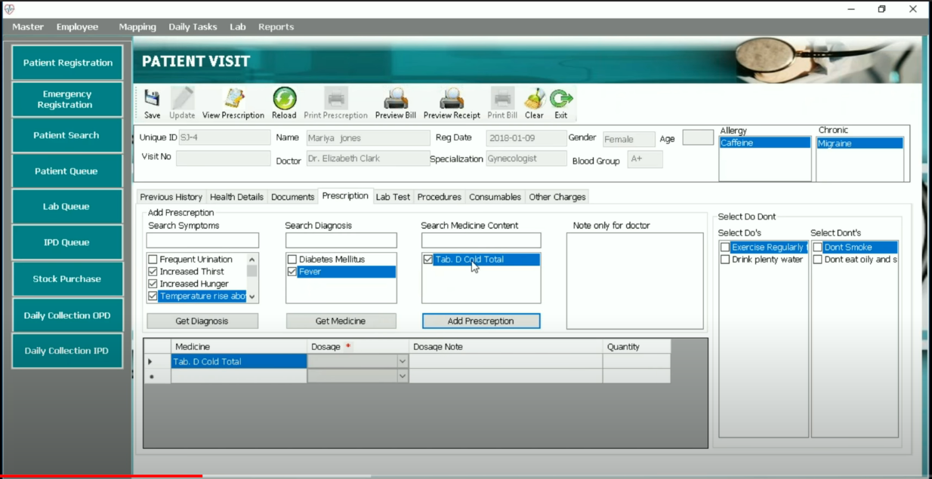

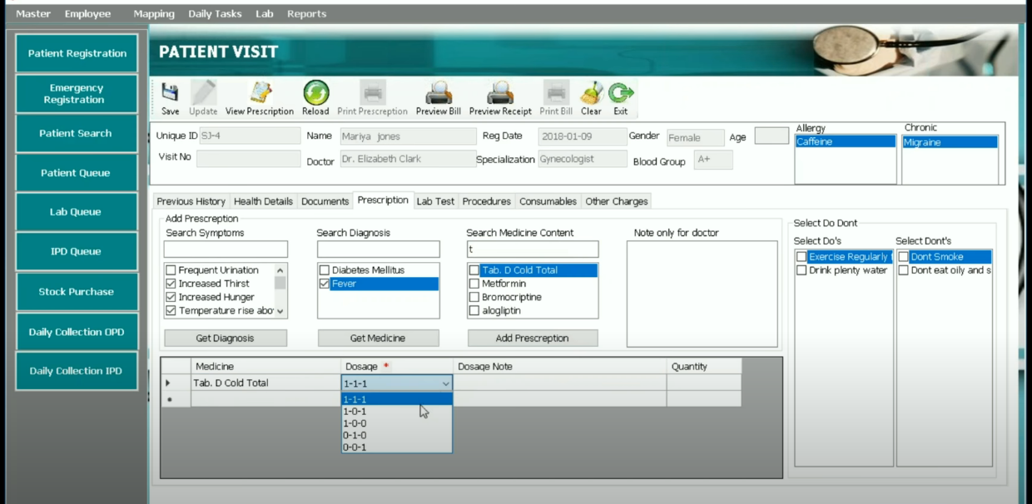

This section is used to prescribe medicines by the doctors.

Expectations(Used to write test scenarios):

1. When user selects options from symptoms and clicks on Get Diagnosis section, the related diagnosis results should be displayed.
2. When user selects options from diagnosis and clicks on Get Medicine section, the related medicine results should be displayed.
3. When user selects medicines and clicks on add prescription, the medicine should be added to the prescription below.
4. User should be able to select medicines independent of the Symptoms and Medicines tab.
5. User should be able to add dosage and quantity to the medicines added in prescription
6. User should be able to write notes for the patient
7. User should be able to select Do’s and Don’t for the patient

* **Lab Test:**

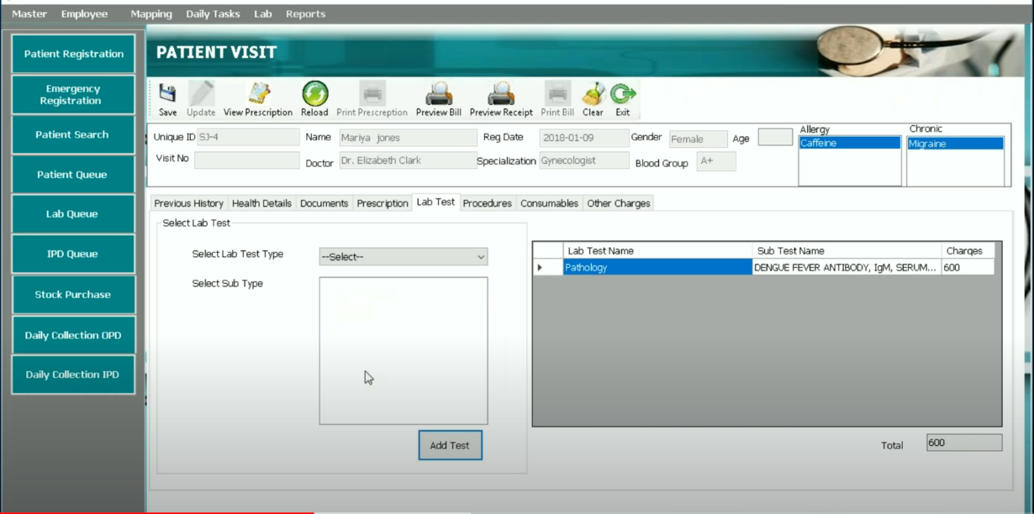

This tab is used to suggest Lab Tests to the patient if any.

Expectations(Used to write test scenarios):

1. User should be able to select lab test and its sub-type.
2. When user clicks on add test button, the added test should get displayed to the right hand side module along with price.
3. The total amount of tests added should get displayed in the total section

* **Procedures:**

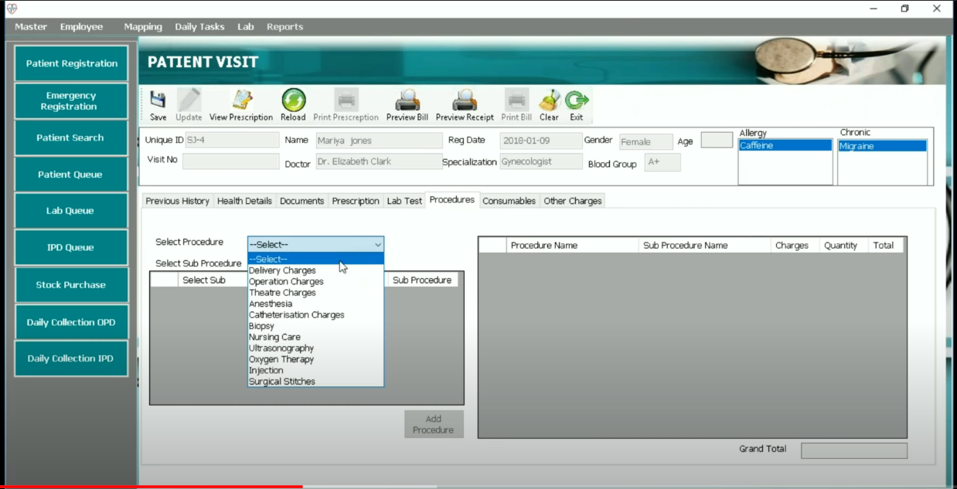

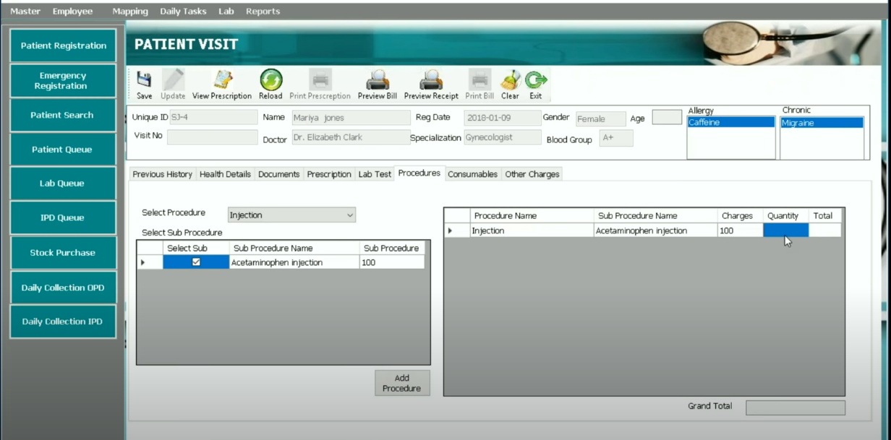

Expectations(Used to write test scenarios):

1. User should be able to select the procedures from the option available.
2. The added procedure should get displayed to the right hand side section.
3. Based on the quantities added the grand total amount should be calculated correctly.